To: Kindergarten Administration 2 Section (Room 2329, 23/F, Wu Chung House, 213 Queen’s Road East, Wan Chai, Hong Kong) Appendix 1

Kindergarten Education Scheme (Scheme)
Staff Relief Grant for Staff Taking Paid Maternity Leave
Application Form

Name of Kindergarten (KG):__________________________________________________ | District:___________ | School No.:_____________________
[Name of school contact person, post title and phone number (for EDB’s enquiries where necessary in processing the application):________________________________________________]

Owing to staff taking paid maternity leave (ML), our school is applying for reimbursement of the salary paid to the substitute staff and the contribution made by our school for him/her under the Mandatory Provident Funds (MPF) Scheme (if applicable). Details are as follows:

Part A Particulars of the Staff Concerned (*Please delete where inappropriate)

Staff taking paid ML |  |  |  | Substitute staff (Note 2)
Name and Post | Monthly salary | Period of paid ML  (Not more than 14 weeks) |  | Name of substitute staff | For supply teacher, possessing a Certificate in Early Childhood Education or above qualifications  (Yes/No) | Substitute period  From  (dd/mm/yyyy)  to  (dd/mm/yyyy) | Daily salary /  Monthly salary  (Note 3)  (a) | Actual no. of working days / months  (b) | Salary  (Not including MPF contribution)  (c) | Employer’s contribution under the MPF Scheme (if applicable)  (d) | Total amount  (Note 4)  (e)
Name  Post (Note 1): | Monthly salary:  $ | From  (dd/mm/yyyy)  to  (dd/mm/yyyy) |  | 1. |  |  | Daily/Monthly* salary  $ | Month(s) Day(s) | $ | $ | $
 |  |  |  | 2. |  |  | Daily/Monthly* salary  $ | Month(s) Day(s) | $ | $ | $
 |  |  |  | 3. |  |  | Daily/Monthly* salary  $ | Month(s) Day(s) | $ | $ | $
 |  |  |  |  |  |  |  |  | Total of column(e): |  | $
 |  |  | Proportion of work in the KG portion joining the Scheme  for the staff taking paid ML (Note 5): % |  |  |  |  |  | Total amount applied:  $ (Total of column(e)) x % |  | $

Note
- Please enter the alphabet representing the post from the list below –
- Teacher | - Clerk | - Janitor | - Cook | - Other (Please specify, e.g. Teaching Assistant)
- If the staff taking ML does not meet the requirements for taking paid ML in accordance with the Employment Ordinance (Cap. 57), even though the school has employed a substitute staff to perform her duties, the school cannot apply for the grant.
- The salary of the substitute staff should not be higher than that of the staff taking paid ML. Should the salary of the staff taking paid ML change (e.g. a pay rise according to the established incremental date), the salary of the substitute staff will not be affected.
- The amount applying for reimbursement of each substitute staff should not be higher than the relevant amount as indicated in Appendix 3.
- If the KG does not have a child care centre section or operate a non-local curriculum stream, please fill in 100%. If the staff taking paid ML also works in the child care centre section and/or the non-local curriculum stream at the same time, the KG should fill in her proportion of duties in the KG section joining the Scheme by apportionment based on her duties or the number of students.
- The KG should employ one substitute staff to take up the duties of a staff taking paid ML. If the KG needs to employ more than one substitute staff because of special circumstances (e.g. the first substitute staff resigns in the middle of the employment period), the KG should list out the particulars such as the name, employment period, salary, etc. of each substitute staff separately.
- If a substitute staff who is employed on a monthly-rated basis does not serve for an entire month, his/her salary of that month will be calculated on a pro-rata basis [average daily salary of the substitute staff (i.e. monthly salary of the substitute staff x 12 months / 365 days) x no. of calendar days of employment in that month].

Part B Supporting Documents to be Submitted

Our school has completed the above application form and submitted the following documents certified by the school supervisor/principal:
□ 1. Original copy of the medical certificate of the staff taking paid ML (specifying the expected and/or actual date of confinement);
□ 2. Duplicate copy of documentary proof of the salary of the staff taking paid ML;
□ 3. Original copy of the salary payment receipt(s) signed by all the substitute staff (a sample is at Appendix 3 for reference);
□ 4. Duplicate copy of the qualification document of the supply teacher (if applicable);
□ 5. Others (please specify if necessary: )

Part C Declaration
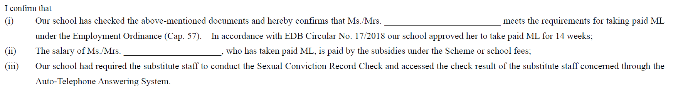
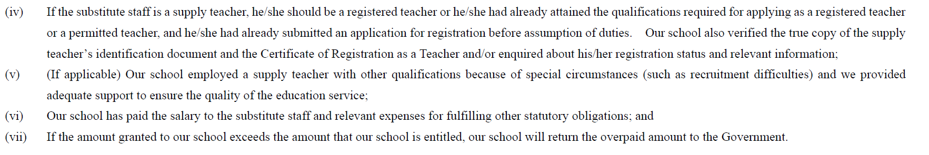

School Chop
Signature of School Supervisor/Principal*:
Name of School Supervisor/Principal*: Date of Application:

